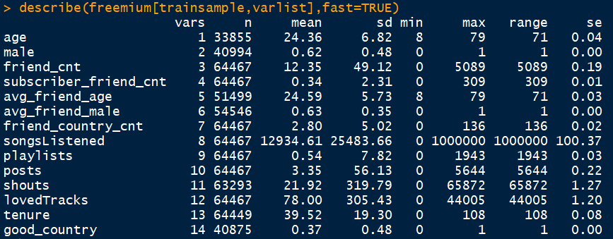

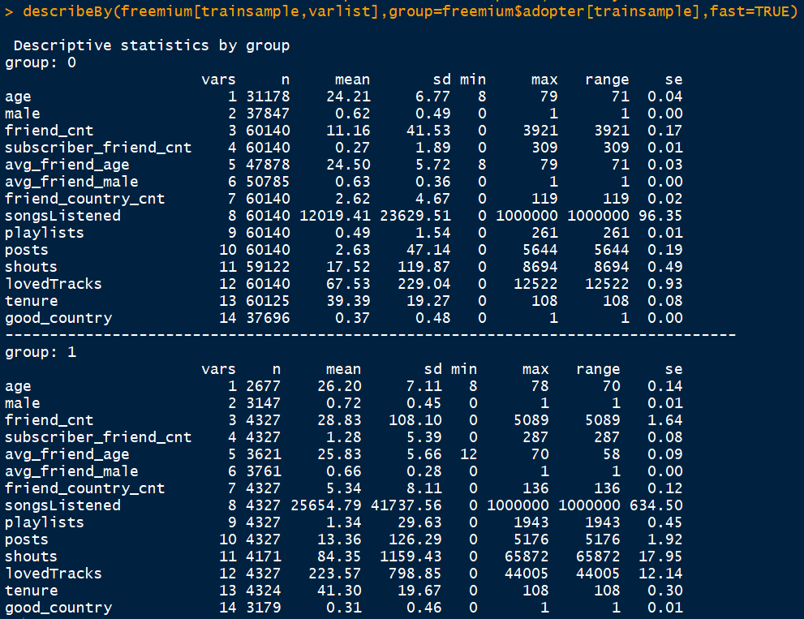

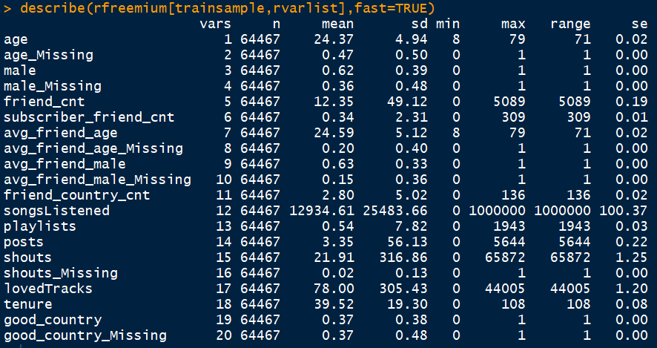

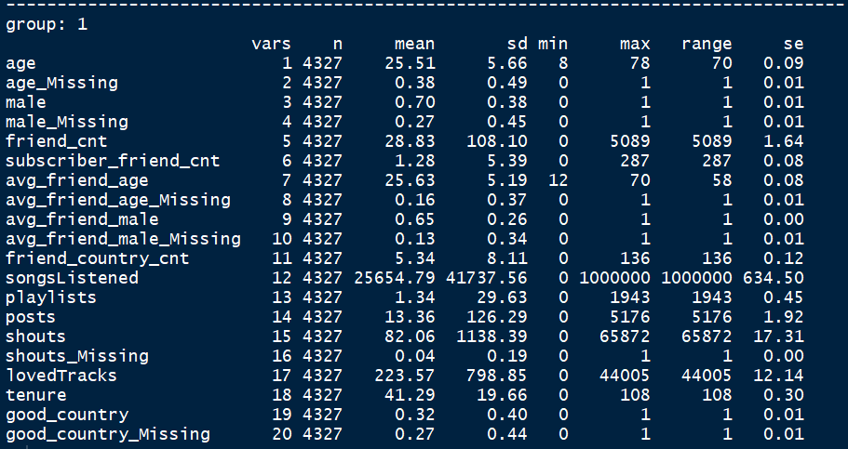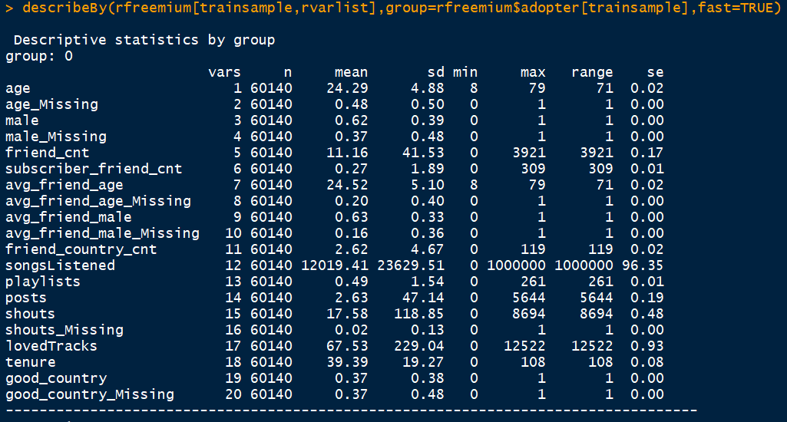

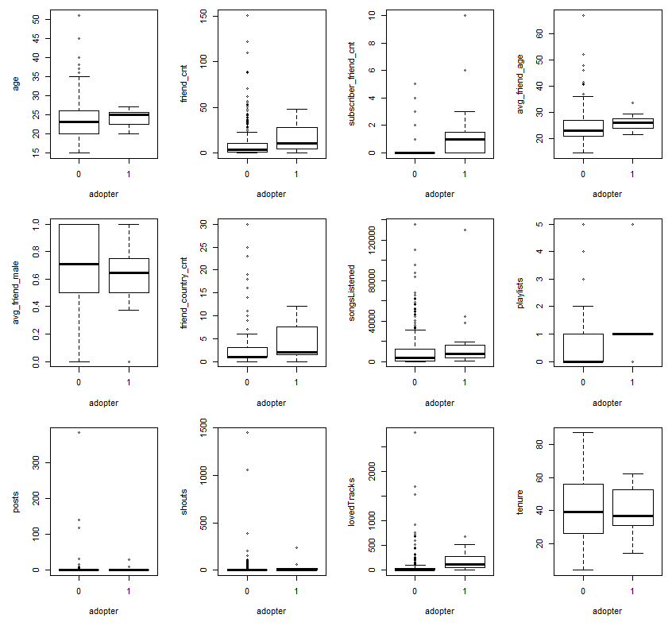

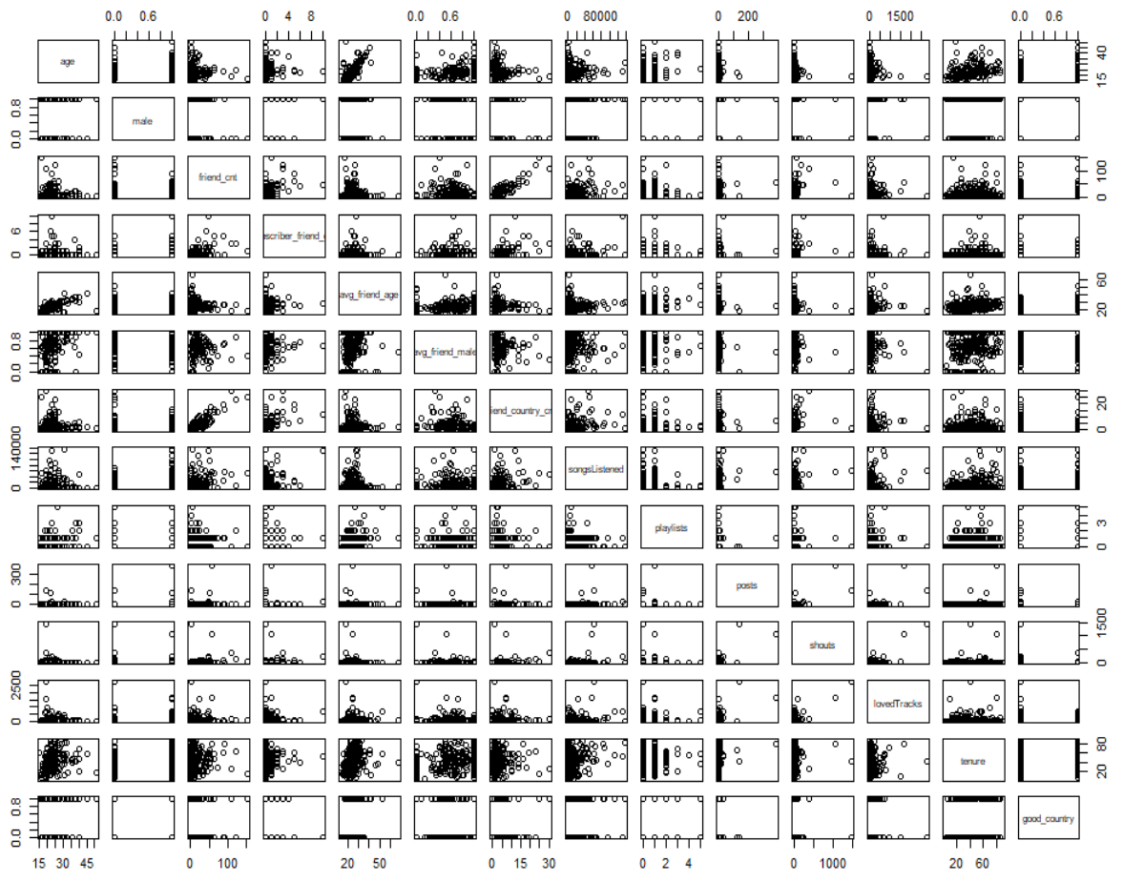

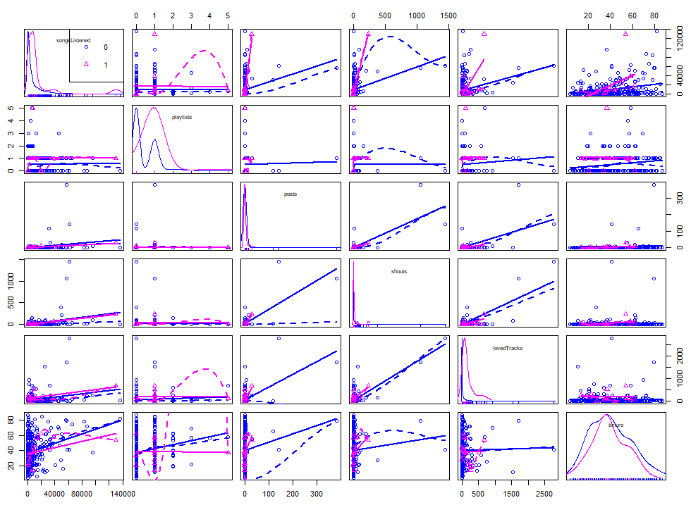

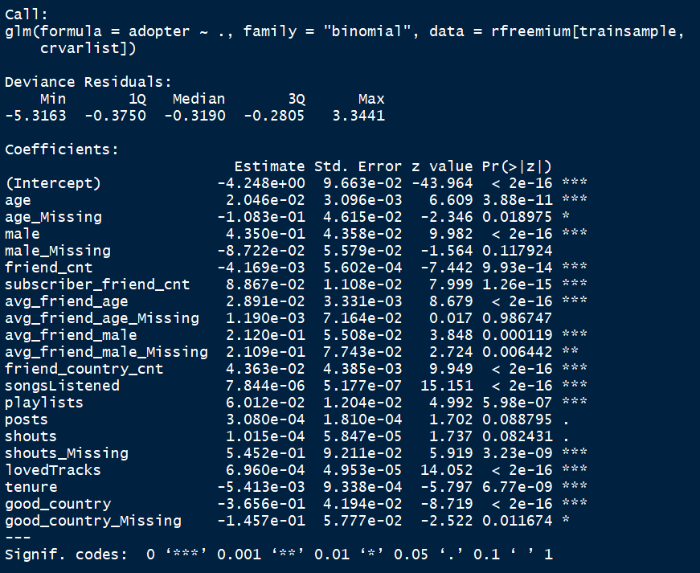

Step wise regression on “full”- 10 steps

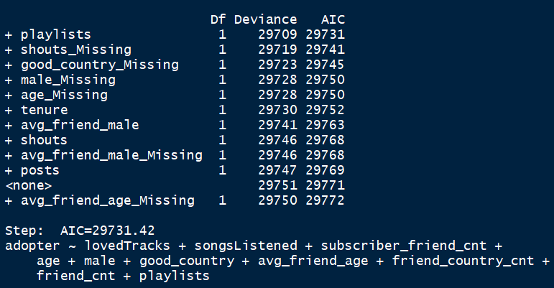

Step wise regression on “full”- 15 steps

* Includes nonsense features

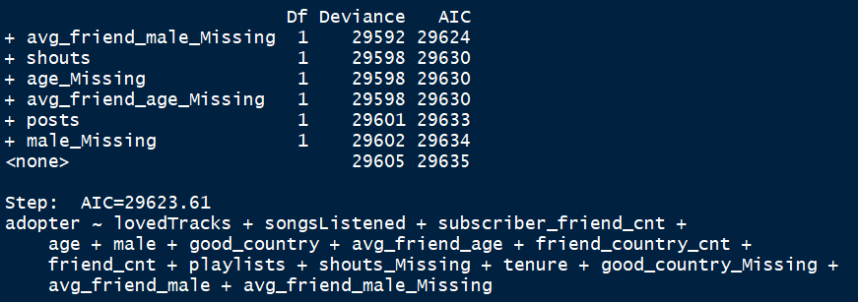



False positive rate is most important factor. The costliest mistake is False Negatives - missing a potential subscriber.

Statistic: AOC of ROC curve

10 steps “full” model

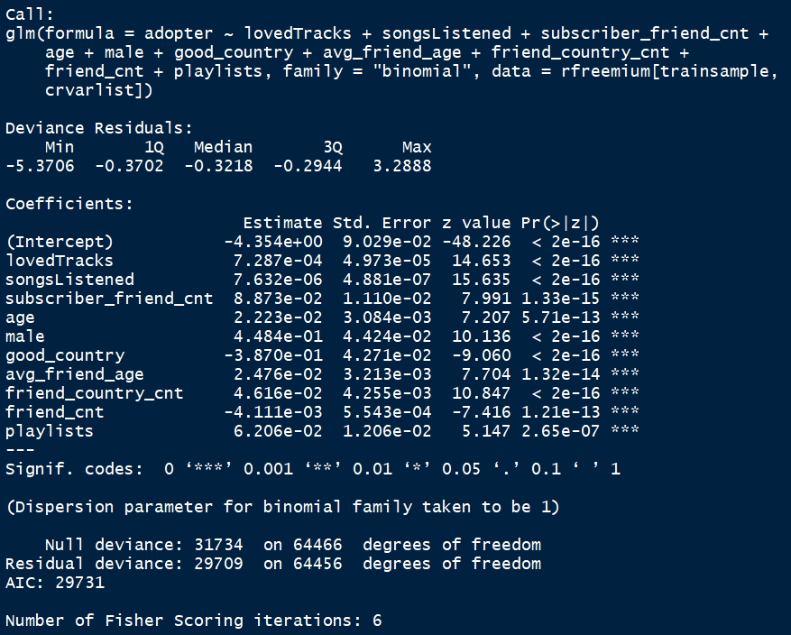



15 steps fulli model

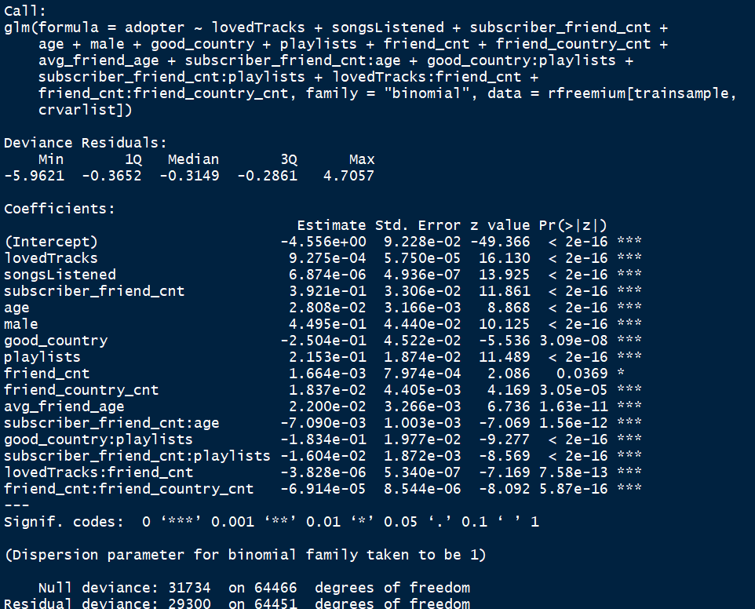

Male

Subscriber_friend_cnt

Playlists

Strongest negative

Good_country

Good_country:playlists

Ubscriber_friend_cnt: playlists



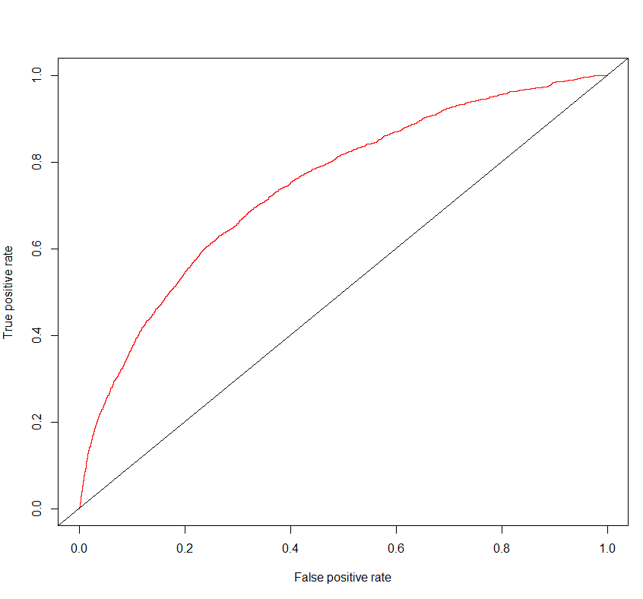

A way to promote social engagement on the platform could be to provide  a free one-month premium subscription to users. This additional features and the absence of advertisements would likely prompt users to spend more time on the site during their trial period. We suspect that these higher usage rates would in turn drive more social interaction, which has historically been the case with premium subscribers. Ideally, at the end of the subscription period, these users will now find more value in the site because of the social networks that they’ve developed. That, along their experience of using the premium site features ad free, may just tip these users from “free to fee”. The only risk we see in this proposal would be a temporary loss of ad revenue from those who take advantage of the promotion. This does not appear to be a large concern since ads only account for a small portion of the company’s revenue. Also, a large portion of the losses could be averted by only offering the promotion to those that are likely to become subscribers. The logistic regression model we developed provides a good starting point for identifying these users.